Contents
Almond 3
Apple 4
Apricot 5
Ash tree 6
Avocado 7
Beech tree 8
Blueberry 9
Cacao 10
Cannabis 11
Cedar 12
Cherry 13
Citrus – general 14
Coffee 15
Corn 16
Cotton 17
Cypress 18
Dates 19
Eucalyptus 20
Fig 21
Fir (Douglas Fir tested) 22
Grape – Wine and Table 23
Grapefruit 24
Hazelnut 25
Hornbeam (Carpinus Betulus) 26
Kiwi 27
Lemon 28
Lime 29
Lychee/longan 30
Macadamia 31
Mandarin orange 32
Mango 33
Maple 34
Oak 35
Olive 36
Orange 37
Peach/nectarine 38
Pear 39
Pecan 40
Pepper (Bell pepper tested) 41
Persimmon 42
Pine 43
Pistachio 44
Pomegranate 45
Pomelo 46
Prune/plum 47
Redwoods 48
Soil 49
Soybean 50
Spruce 51
Tobacco 52
Tomatoes 53
Walnut 54

Almond
Performance:
- Excellent. Recommended for commercial use.
- Sensor data matches the pressure chamber, but can read 1-3 bars wetter during the spring.
- Thoroughly validated and used commercially.
Installation tips:
- Install after leaf out, on a 2+” branch. Installation into main trunk can be difficult if the bark is thick. Big and small sensors can work well.
- Sensors should be reinstalled after the winter, otherwise SWP will read too wet.
Troubleshooting:
- Sensor install site can get blocked and sensor will read too wet, with little to no diurnal pattern. Reinstall.
- Sensors can get disconnected from xylem due to breaks in the mating compound. The sensors will then read very negative values during hot part of day. Reinstall.
Guidelines:
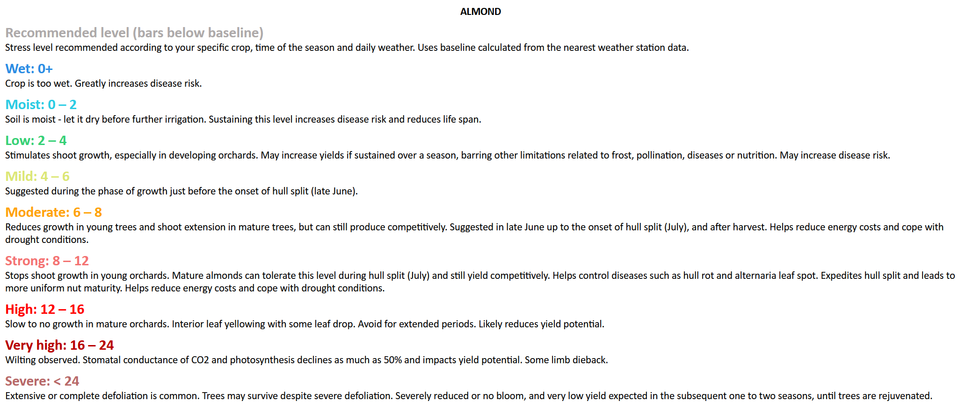
References:
- Using the Pressure Chamber for Irrigation Management in Walnut, Almond, and Prune

Apple
Performance:
- Excellent. Recommended for commercial use.
- Sensor data matches the pressure chamber.
- Thoroughly validated and used commercially.
Installation tips:
- Very easy install, apple xylem is usually uniform and healthy.
- Ensure the bubble wrap insulation is loose so that excess moisture can evaporate, particularly important in wetter climates.
- Sensors may freeze during the winter if temperatures go below 0 °C
- Big or small sensors can work well, depending on the trunk diameter.
Troubleshooting:
- Main issue seen is sensors reading 0 when trunk is wet. Attach insulation loosely to allow evaporation.
Guidelines:
- Not yet established. Recommend irrigation by SWP trend.
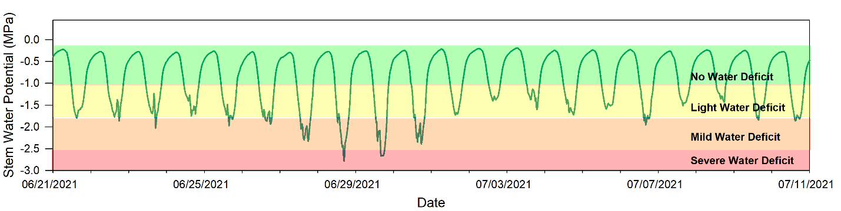
Sample guidelines for apple from Washington State University
References:
- Microtensiometers: a new tool to monitor your apple trees for deciding when and how much to irrigate
- Trunk Water Potential Measured with Microtensiometers for Managing Water Stress in “Gala” Apple Trees

Apricot
Performance:
- Untested, but sensors generally work well in stone fruits.

Ash tree
Performance:
- Untested.
Installation tips:
- Likely will need to use thick-bark installation method.

Avocado
Performance:
- Recommended for very early experimental use only.
- Normal sensor installation usually gets flooded and reads zero.
- Heading cut installation is being tested to solve this issue, and the results look promising. The validation continues. We will announce when avocado is ready for external testing.
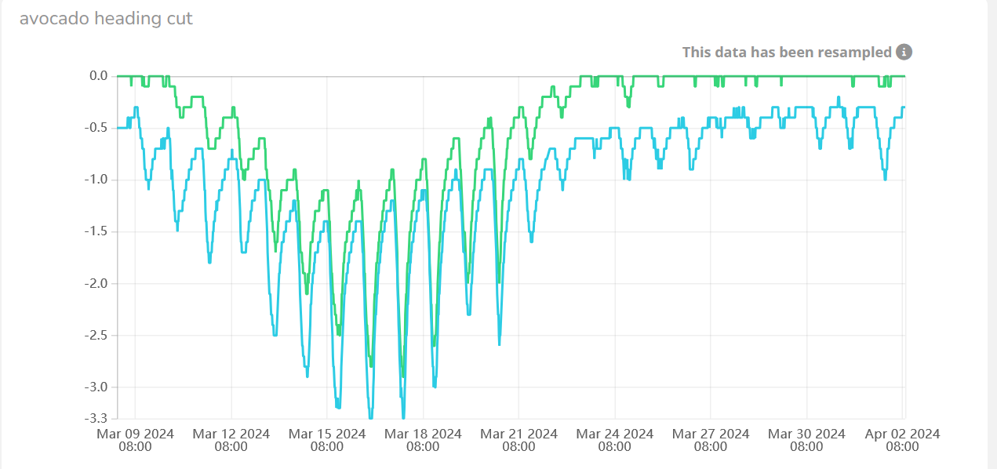
Figure 1 Typical behavior seen in avocado. Heading cut install.

Beech tree
Performance:
- Recommended for experimental use.
- Initial testing showed two sensors installed into same tree measured SWP and agreed with each other. More testing needed.
- Potential issues seen where sensors break after 2-3 months installed. We’re looking into this further.
Installation tips:
- Use thick-bark installation method.

Blueberry
Performance:
- Recommended for experimental use.
- Initial testing of small probes shows consistently good data that matches the pressure chamber trend. Still under testing.
Installation tips:
- Recommend using the 7mm sensor if the trunk is >16mm diameter, otherwise use the 3mm sensor.
References:
- Irrigation of Blueberry, David Bryla
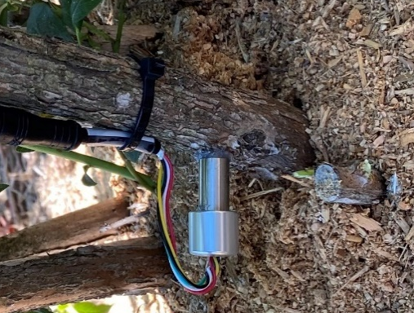

Cacao
Performance:
- Recommended for experimental use.
- New small 7mm sensors give good reasonable data, but our testing is limited.
Installation tips:
- Use our new 7mm sensors!
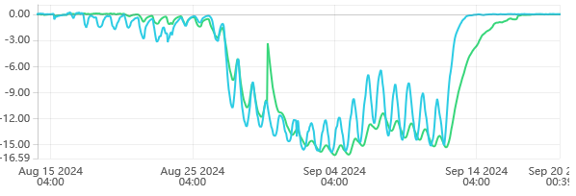

Cannabis
Performance:
- Small probes installed shallowly give reasonable data and agree with each other, at least for a few weeks. Our one dataset does show the sensors began to diverge after a few weeks (may be fixed by reinstalling the sensor).
- Recommended for experimental use.
Installation tips:
- Installation requires care because hemp stem is soft and hollow.

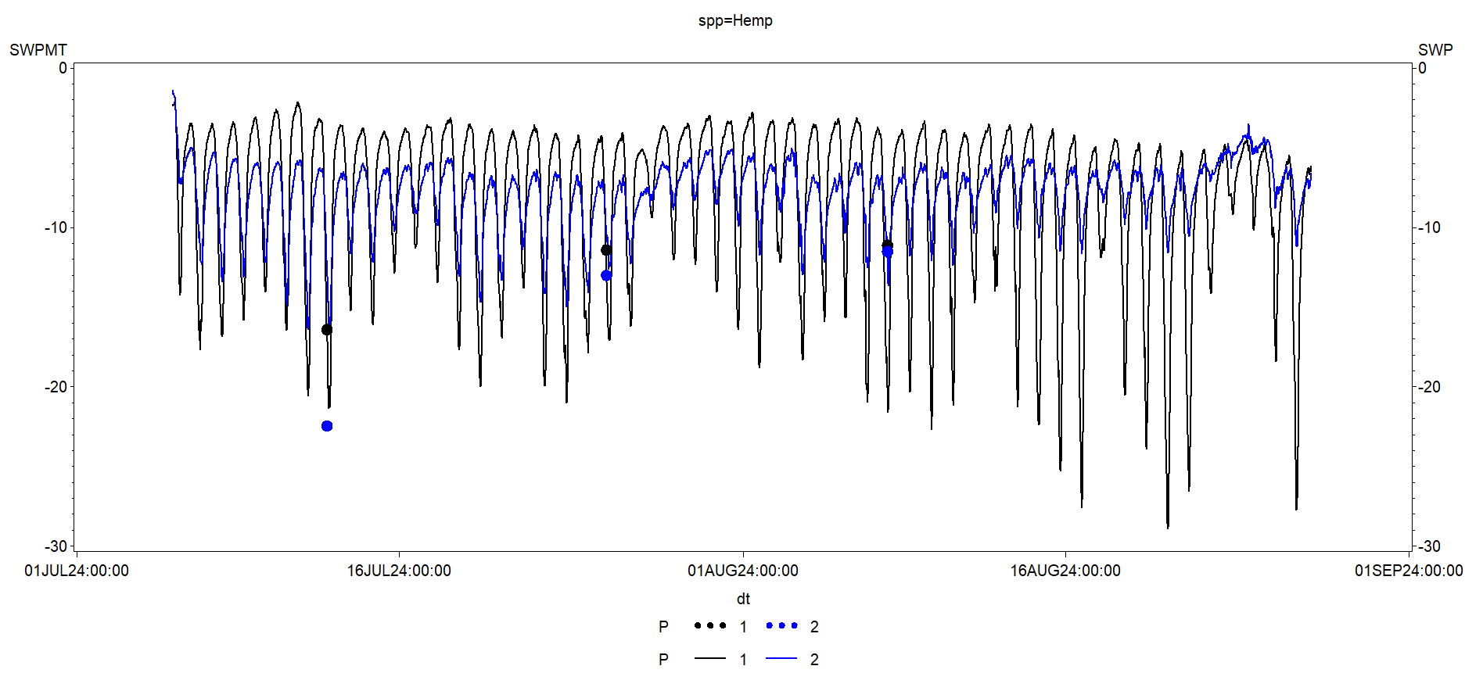

Cedar
Performance:
- Untested.
Installation tips:
- Should use thick-bark tree installation method.

Cherry
Performance:
- Recommended for experimental and commercial use.
- Guidelines are still missing, so irrigation should follow sensor trend and grower experience.
- Good results seen in research and commercial orchards.
Installation tips:
- Similar to almond, sensors should be installed in scaffolding branches, after leaf-out.
- Reinstall sensors after the winter for best results. Sensors may freeze in < 0 °C temperatures.
- Big or small probes will work well.
Troubleshooting:
- Limited testing in cherry. Likely to see similar issues to almond.

Citrus – general
Performance:
- Recommended for experimental use only.
- Testing in citrus has shown mixed results with the BIG probes, but the new probe installation appears to work well. Try it out!
Installation tips:
- You should only use our new 7mm probes for citrus – they work best.
Troubleshooting:
- If sensor readings appear non-sensical, recommend removing and reinstalling sensor.

Coffee
Performance:
- Recommended for experimental use, and initial commercial testing.
- Initial results are very promising, data is consistent, and correlates well with the pressure chamber, though the measurements are somewhat different. We are exploring the reasons for this discrepancy.
Installation tips:
- Shallow installation with the new small probe design is likely critical. Requires small probes.

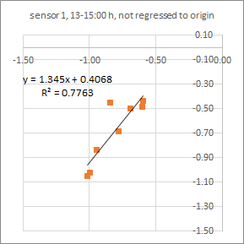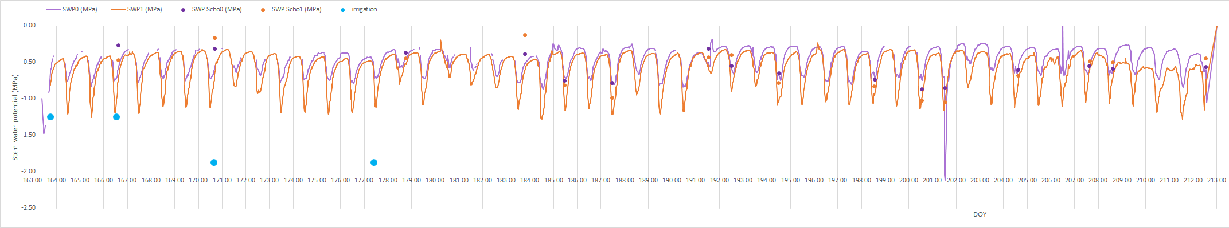
Preliminary data courtesy of Teresa Afonso do Paço.

Corn
Performance:
- Small probes installed shallowly give reasonable data and agree with each other.
- Recommended for experimental use.
Installation tips:
- Installation requires care because corn stalk is soft.

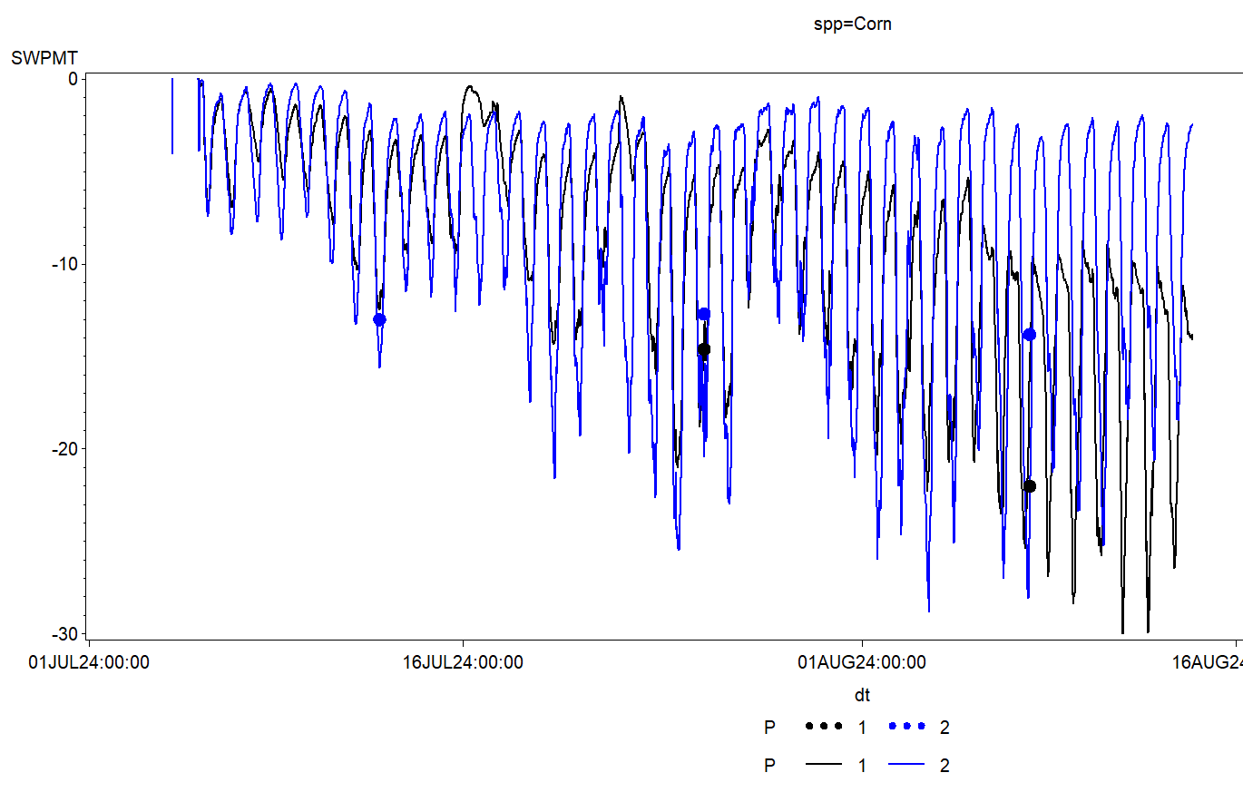

Cotton
Performance:
- Recommended for experimental use and initial commercial field trials.
- Sensor measurements fit the pressure bomb very well, but some variability seen across years.
Installation tips:
- Recommend using the smaller 3mm sensor due to small trunk size of cotton.
References:
- Bomb Your Cotton for Maximum Profit!!
- Monitoring cotton water status with microtensiometers
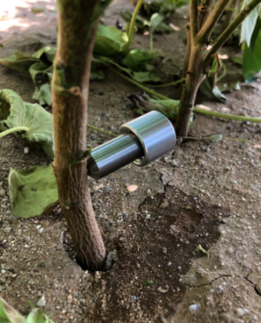

Cypress
Performance:
- Untested.
Installation tips:
- Will need to use thick-bark installation method.
- Psychrometry has been used to measure SWP in this species, so microtensiometers will very likely work as well.

Dates
Performance:
- Untested.
Installation tips:
- Installation method needs to be developed due to date palm’s unique trunk structure. It may be possible to install sensors into leaf stem.

Eucalyptus
Performance:
- Recommended for experimental use.
- Good results seen in Corymbia citriodora.
Installation tips:
- Will likely need the thick bark installation kit.

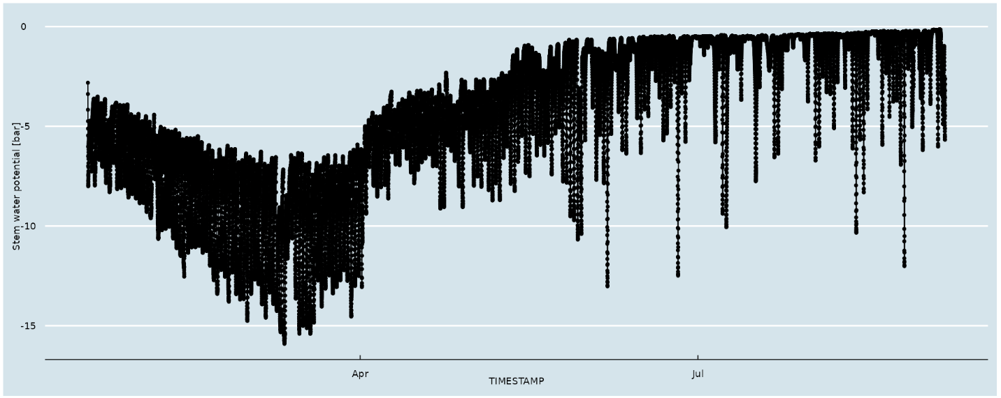

Fig
Performance:
- Recommended for experimental and commercial field trials.
- Sensor measurements fit the pressure bomb very well.
Troubleshooting:
- Fig and related species are known for producing lots of latex. The latex generally does not interfere with sensor measurement. But if sensor is installed too shallowly, latex may block measurement and the sensor should be reinstalled.

Fir (Douglas Fir tested)
Performance:
- Recommended for experimental use.
- Initial trials showed good data. Not validated against the pressure chamber.
Install tips:
- Likely will need to use thick-bark installation method.

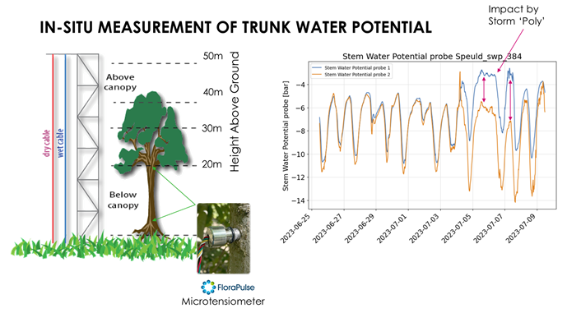
Credit: Yijian Zeng

Grape – Wine and Table
Performance:
- Recommended for experimental and commercial use.
- Sensor readings generally correlate well against the pressure chamber.
Installation tips:
- Use the 7mm probes only, and install into a vine that is at least 0.75” in diameter.
- Sensors must be installed into vines that are large enough and healthy.
- Consider taking a core sample of nearby vines to ensure xylem is healthy. This is especially important if the vines are exposed to conditions that damage the xylem: trunk diseases (Eutypa, black foot, etc.), heavy water stress for years, sub-freezing temperatures.
- Sensors should be installed after leaf-out and re-installed each year. That being said, we have seen sensors work well for multiple years without re-installation (we’re looking into this).
Troubleshooting:
- Sensors can get disconnected from xylem due to breaks in the mating compound. The sensors will then read very negative values during the hottest part of day. Reinstall.
- Sensor data will be non-sensical if sensors are installed into damaged/diseased/inactive part of wood. If your vineyard has lots of wood disease, consider installing sensors into younger vines that may be healthier.
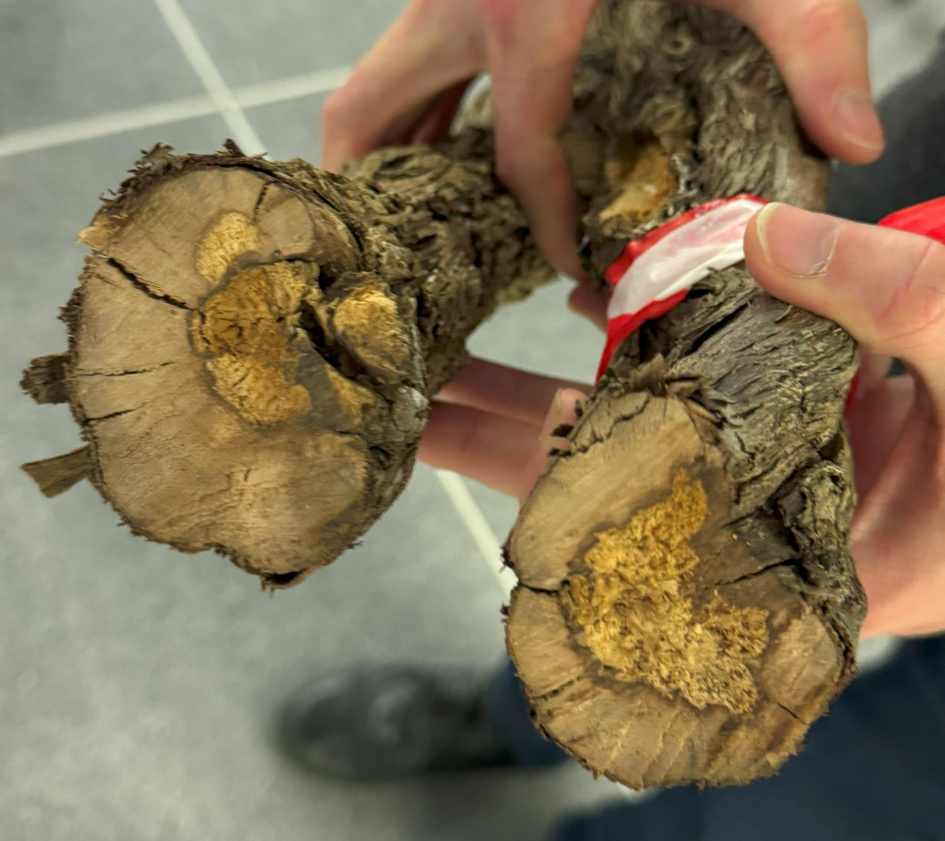
Figure 2. Trunk disease will prevent accurate SWP readings.
References:
- Scheduling irrigation with a pressure chamber. Part 1. Part 2.
- What it’s like to have real time plant stress

Grapefruit
Performance:
- Recommended for experimental use.
- Initial testing with 7mm probes looks good.

Hazelnut
Performance:
- Recommended for experimental use.
- Initial testing showed good correlation with the pressure chamber.

Hornbeam (Carpinus Betulus)
Performance:
- Recommended for experimental use.
- Initial testing of 9mm sensors looks excellent. See reference.
Installation tips:
- Thick bark method required.
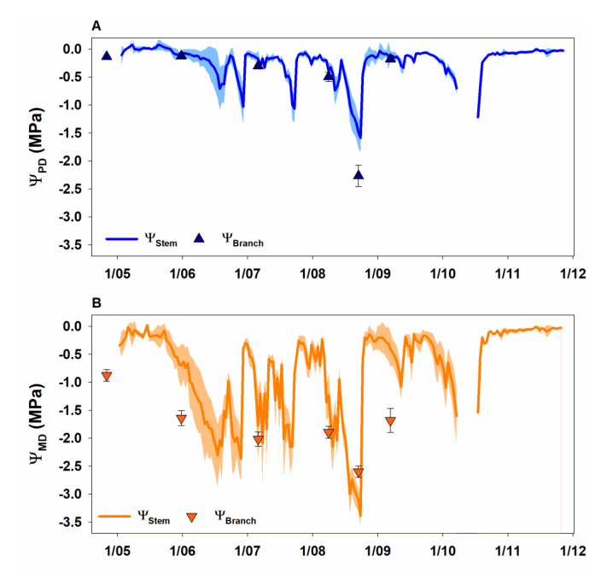
References:
Continuous stem water potential measurements of a diffuse-porous tree species offer new insights into tree water relations. Simon Haberstroh 2024.

Kiwi
Performance:
- Recommended for experimental use.
- Initial testing showed mixed results – some sensor installations performed well, whereas others appeared to get flooded.
Installation tips:
- We expect the new 7mm sensors will give better results. FloraPulse is looking for a partner to test in kiwi in California.

Lemon
Performance:
- Recommended for experimental use.
- Initial testing with 7mm probes looks good!

Lime
Performance:
- Untested. Will probably work similarly to other citrus fruits.

Lychee/longan
Performance:
- Untested.

Macadamia
Performance:
- Untested.
- We are looking for a partner to test the new 7mm sensors in macadamia. Contact us!

Mandarin orange
Performance:
- Recommended for experimental use.
- One commercial tester, with the BIG probes, stated he “was happy with the data. Although he noted there was a fixed offset when compared to bomb measurements, the correlation made sense”.
- We expect the new 7mm probes will give even better results.

Mango
Performance:
- Recommended for experimental and initial commercial use.
- Sensor testing by commercial grower was successful and met customer expectations.
- Correlation against the pressure bomb has not been tested, and irrigation thresholds are undeveloped. Recommend irrigating according to the sensor trend and past experience.
Troubleshooting:
- Mango trees produce latex. This is generally not an issue, but can happen if the sensors are not installed deeply enough. If sensors begin to read zero for more than a couple of days, recommend reinstalling them.

Maple
Performance:
- Not tested. It is possible that sensors may flood due to well-known sweet maple sap.
- Heading cut type install could give good data in this species.
Installation tips:
- Thick bark may necessitate using the thick-bark installation method.

Oak
Performance:
- Untested.

References:
- Using midday stem water potential to assess irrigation needs of landscape valley oaks

Olive
Performance:
- Recommended for experimental and commercial use.
- Favorable comparison with the pressure chamber.
Installation tips:
- Do not use in fields where SWP is expected to drop below -35 bars.
Troubleshooting:
- Depending on the region, olive trees are water stressed to -60 bars or lower. Under such negative water potentials, FloraPulse sensors will invariably cavitate and become unusable. We thus only recommend installing FloraPulse sensors where SWP is generally above -35 bars.
References:
- Establishing a Reference Baseline for Midday Stem Water Potential in Olive and Its Use for Plant-Based Irrigation Management

Orange
Performance:
- Recommended for experimental use.
- Initial testing with 7mm sensors looks promising.

Peach/nectarine
Performance:
- Recommended for experimental and initial commercial use.
- Initial testing showed favorable results, but more testing needed.

References:
- Plant water stress derived indexes from water potential and diameter fluctuations measurements. Conesa 2023
- Moisture management in peaches – Soil Doctor tests FloraPulse in peaches

Pear
Performance:
- Recommended for experimental and commercial use.
- Favorable comparison with the pressure chamber.
References:
- Microtensiometers Accurately Measure Stem Water Potential in Woody Perennials

Pecan
Performance:
- Recommended for very early experimental use.
- Normal installations get flooded due to excessive sap production at the installation site.
- Heading cut install seems to give at least decent data, but more validation/testing is needed. We’ll keep testing and announce when we’re ready for commercial testing.
Installation tips:
- If you wish to try various installation methods in pecan – go for it!

Pepper (Bell pepper tested)
Performance:
- Recommended for experimental and initial commercial use.
- First season field trial showed good correlation with the pressure chamber.
Install tips:
- Recommend using the 3mm small sensor for this crop due to the small trunk size.
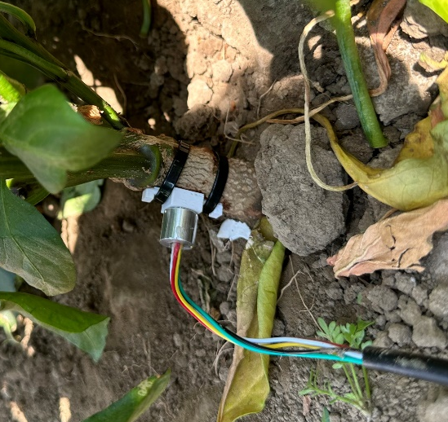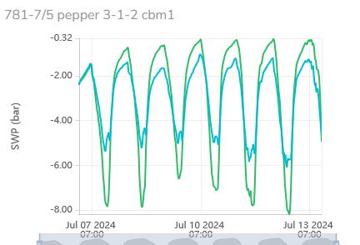
Pepper installation with 3D printed jig that holds the sleeve in place.

Persimmon
Performance:
- Not recommended.
- Black oozing from sensor wound prevents measurement.
- It’s possible that our new 7mm probes will work better, but this needs to be tested.

Pine
Performance:
- Initial testing shows sensor can work well!
Installation tips:
- Will need thick-bark installation method.
- There is concern about resin ducts blocking the sensor measurement, but initial testing has not shown this to be a problem.
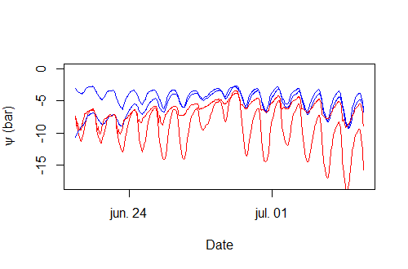

Pistachio
Performance:
- Recommended for experimental use.
- Field trials show good agreement between the sensor and pressure chamber.
- Sensors sometimes randomly get flooded and proceed to measure zero SWP. Reinstalling the sensor will usually fix this. We are testing to better understand what causes this wounding response and how to prevent it.
Troubleshooting:
- Pistachio trees produce latex, which can (randomly) interfere with sensor measurement. Sensors should be reinstalled if they get stuck at zero SWP.
References:
- 2021 Pistachio Irrigation: Mitigation Strategies for Drought
- Pistachio Irrigation: Determining Water Needs and Managing Drought
- Water stress thresholds for regulated deficit irrigation in pistachio trees: Rootstock influence and effects on yield quality

Pomegranate
Performance:
- Untested. We are looking for a testing partner in California! Contact us.

Pomelo
Performance:
- Untested. Likely similar result to other citrus crops.

Prune/plum
Performance:
- Excellent. Recommended for commercial use.
- Sensor data generally matches the pressure chamber.
- Thoroughly validated and used commercially.
Installation tips:
- Install after leaf out, on a 2” branch. Installation into main trunk can be difficult if the bark is thick. Big and small sensors can work well.
- Sensors should be reinstalled after the winter, otherwise measured SWP will read too wet.
Troubleshooting:
- Sensor install site can get blocked and sensor will read too wet, with little to no diurnal pattern. Reinstall.
- Sensors can get disconnected from xylem due to breaks in the mating compound. The sensors will then read very negative values during hot part of day. Reinstall.
- Very old or diseased prune trees will sometimes give nonsensical data, such as reading the lowest SWP at night. If this happens, sensors should be installed in a different tree.
Guidelines:
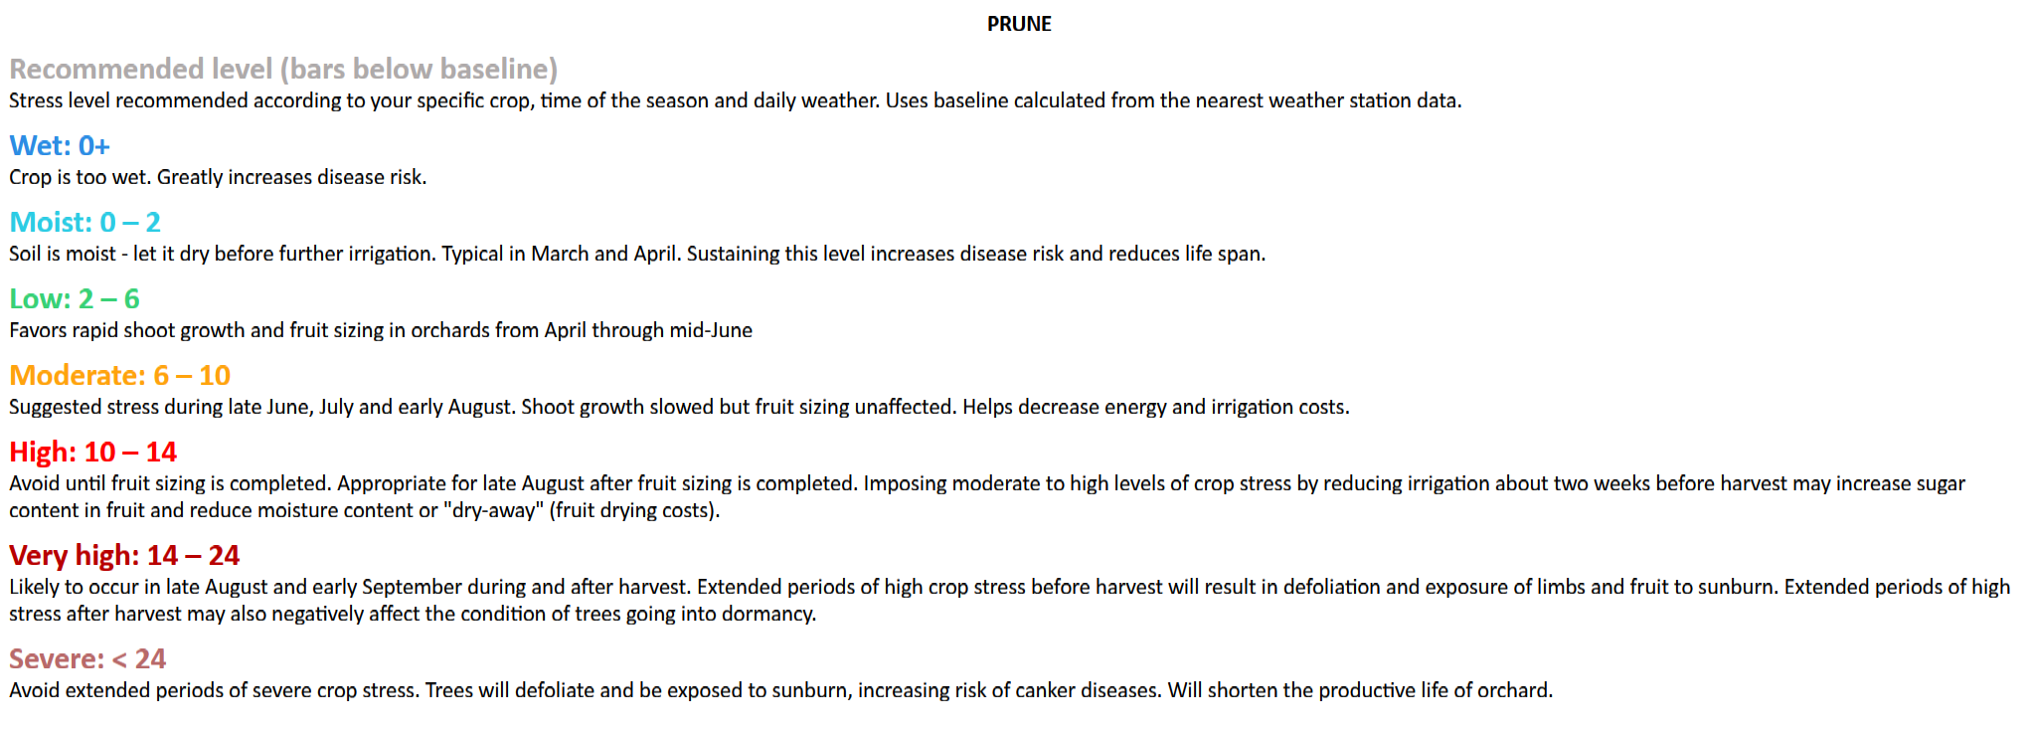
References:
- Using the Pressure Chamber for Irrigation Management in Walnut, Almond, and Prune

Redwoods
Performance:
- Very good. Initial testing shows strong sensor-sensor agreement and consistent diurnals. Recommended for experimental use.
Installation tips:
- Redwood bark can be over 2” thick. You will need to use the thick-bark installation method.
- Be careful with sensors installed in freezing-prone areas. Temperatures below zero can damage the sensors.

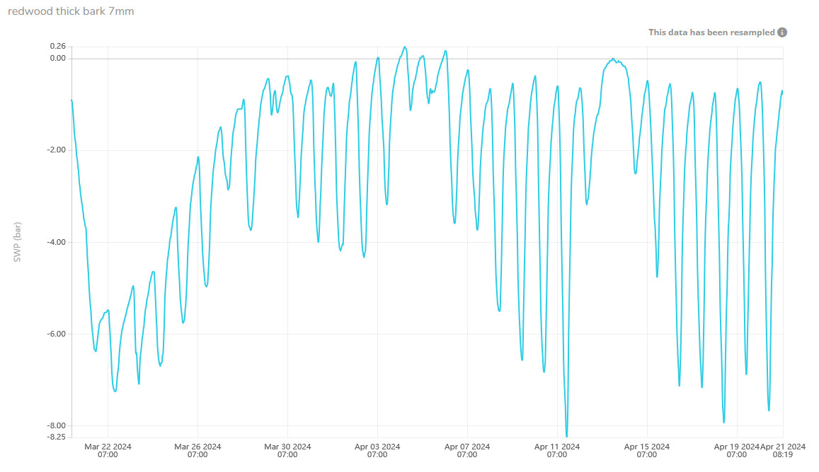

Soil
Performance:
- Microtensiometer sensors not recommended for use in soil. The existing installation method does not translate well to soil installation and would give inaccurate data. Furthermore, the sensor resolution of ~0.2 bars is too coarse for most soil applications, where the full range is often 0 – 1 bar.
- It’s likely possible to use microtensiometers to measure WP in very dry soils, but the installation method needs development.
Install tips:
- If you wish to try our tensiometers for soil WP, go for it. Just know you’ll need to test and develop an installation method. We would be happy to consult/discuss.

Soybean
Performance:
- Untested.

Spruce
Performance:
- Recommended for experimental use.
- Initial trials showed sensors perform well and correlate favorably with the pressure chamber.
Install tips:
- Will need to use thick-bark install method.
Troubleshooting:
- Freezing temperatures may damage the sensor.

Tobacco
Performance:
- Initial trial started.

Tomatoes
Performance:
- Small probes installed shallowly give reasonable data and agree with each other.
- Recommended for experimental use.
Installation tips:
- Installation requires care because tomato trunks are soft and small.

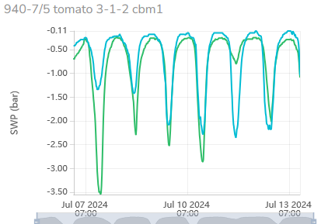

Walnut
Performance:
- Recommended for early experimental testing.
- Normal sensor installations get flooded after a few days and measure zero SWP indefinitely.
- The new heading cut install appears promising and gives reasonable results about 60% of the time. We continue field trial on this crop with UC Davis.
Installation tips:
- Let us know if you wish to try this…
References:
- Using the Pressure Chamber for Irrigation Management in Walnut, Almond, and Prune

